SEMESTER ONE 11 ATAR EXAM 2018

Section One: Research Methods 20% (24 marks)

This section has two (2) questions. Answer all questions. Write your answers in the spaces provided.

Supplementary pages for the use of planning/continuing your answer to a question have been provided at the end of this Question/Answer booklet. If you use these pages to continue an answer, indicate at the original answer where the answer is continued, i.e. give the page number.

Suggested working time: 30 minutes

Question 1 Total 16 marks

A researcher wanted to discover if eating a healthy breakfast affected students’ performance at school. He asked for 100 volunteers from the Year 11 cohort at Pavlov High School. Of his volunteers, he asked 50 to eat a healthy breakfast before school and the other to not eat breakfast before school for one week. Before the day started he would give students the same 20 words and at the end of each day he would ask them to repeat those 20 words back to him. He did this each day for 7 days. He recorded how many correct answers the students gave. His results indicated that a healthy breakfast does improve performance.

1. Write an operational hypothesis for the above experiment (4 marks)

1. State the following for the above research study. (3 marks)
   1. Independent Variable

* 1. Dependent Variable

* 1. Controlled Variables

1. Identify and explain **two(2)** ethical considerations that would need to be followed in the research study (4 marks)

1. Explain what the researcher can conclude from this experiment (3 marks)

1. Identify **one (1)** source of error and **one(1)** way of reducing this error (2 marks)

**Question 2 Total 8 marks**

1. Complete the following table: (4 marks)

|  |  |  |
| --- | --- | --- |
| **Data Collection** | **Example** | **Advantage** |
| **Qualitative** |  |  |
| **Quantitative** |  |  |

1. Identify **two(2)** non-experimental research methods (2 marks)

1. Calculate the following for the set of scores below (2 marks)

88 78 67 82 77 92 73 75 92 83 66

1. Mean:
2. Median:

**End of Section One**

**Section Two: Short Answer 55% (66 Marks)**

This section has eight (8) questions. Answer all questions. Write your answers in the spaces provided.

Supplementary pages for the use of planning/continuing your answer to a question have been provided at the end of this Question/Answer booklet. If you use these pages to continue an answer, indicate at the original answer where the answer is continued, i.e. give the page number.

Suggested working time: 60 minutes

**Question 3 Total 10 marks**

Question 3a refers to the diagram below.

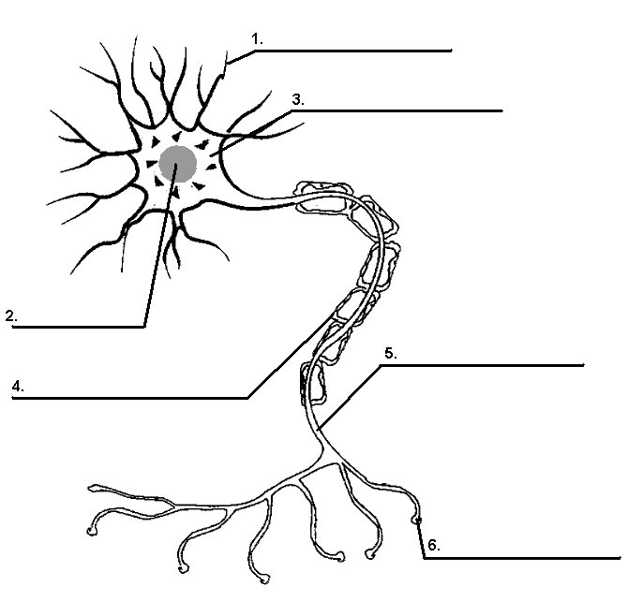

1. Identify the parts of the neuron labelled 1,2,4 and 6 (4 marks)

|  |  |
| --- | --- |
| **Structure** | **Structure Name** |
| 1 |  |
| 2 |  |
| 4 |  |
| 6 |  |

1. Explain the impact of damage to structure 4 (2 marks)

1. Explain how messages are transferred from structure 1 to 6 of adjacent neurons (4 marks)

**Question 4 Total 16 marks**

1. Fill in the following table (8 marks)

|  |  |  |
| --- | --- | --- |
| **Structure** | **Advantages** | **Disadvantages** |
| fMRI |  |  |
| PET |  |  |
|  | Used to investigate functioning of the whole brain |  |
|  |  | Low resolution images produced |

1. Lucy has been having seizures and the doctors believe she has epilepsy, explain how they could use imaging techniques to support this diagnosis (2 marks)

1. Joe has been having trouble sleeping, which imaging technique could be used to find the underlying issue. Explain your answer (2 marks)

1. Compare the functions of the left and right hemisphere of the brain (2 marks)

1. How does communication occur between the hemispheres of the brain (2 marks)

**Question 5 Total 8 marks**

1. Amphetamines are recreational drugs.
2. Explain the physiological effects of amphetamines (2 mark)

1. Explain **two (2)** psychologicalresponses of the body that amphetamine cause (2 marks)

1. Amphetamines can also alter a person’s consciousness. Identify and explain **two (2)** physiological responses that can indicate if a person is in a different state of consciousness. (4 marks)

**Question 6 Total 6 marks**

1. Lily is studying for exams in her bedroom. She always studies at her desk with the fan on and Netflix playing in the background.
   1. Explain in terms of selected and divided attention how Lily could improve her study habits (2 marks)

* 1. Lily’s friend Sarah came over to study and asked for the fan to be turned off as it was too distracting, explain why it does not distract Lily (2 marks)

* 1. Lily’s fan starts to shake, explain the effect this will have on her study habits

(2 marks)

**Question 7 Total 7 marks**

1. Identify and explain the following illusion (3 marks)

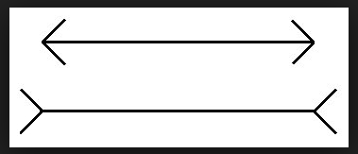

1. Miss Roberts and Miss Hart go to the park, explain how they identify a Frisbee flying towards them in terms of sensation and perception. (4 marks)

Question 9 missing due to containing semester two content

**Question 10 Total 5 marks**

1. Compare and contrast NREM and REM sleep (4 marks)

1. Where does daydreaming occur on the consciousness scale (1 mark)

Section Three: Extended Answer 25% (30 Marks)

This section contains two (2) questions. You must answer both questions.

Suggested working time: 30 minutes

Question 11 15 marks

The Brain is part of the central nervous system and controls both voluntary and involuntary movements.

Using the below diagram, discuss this statement.

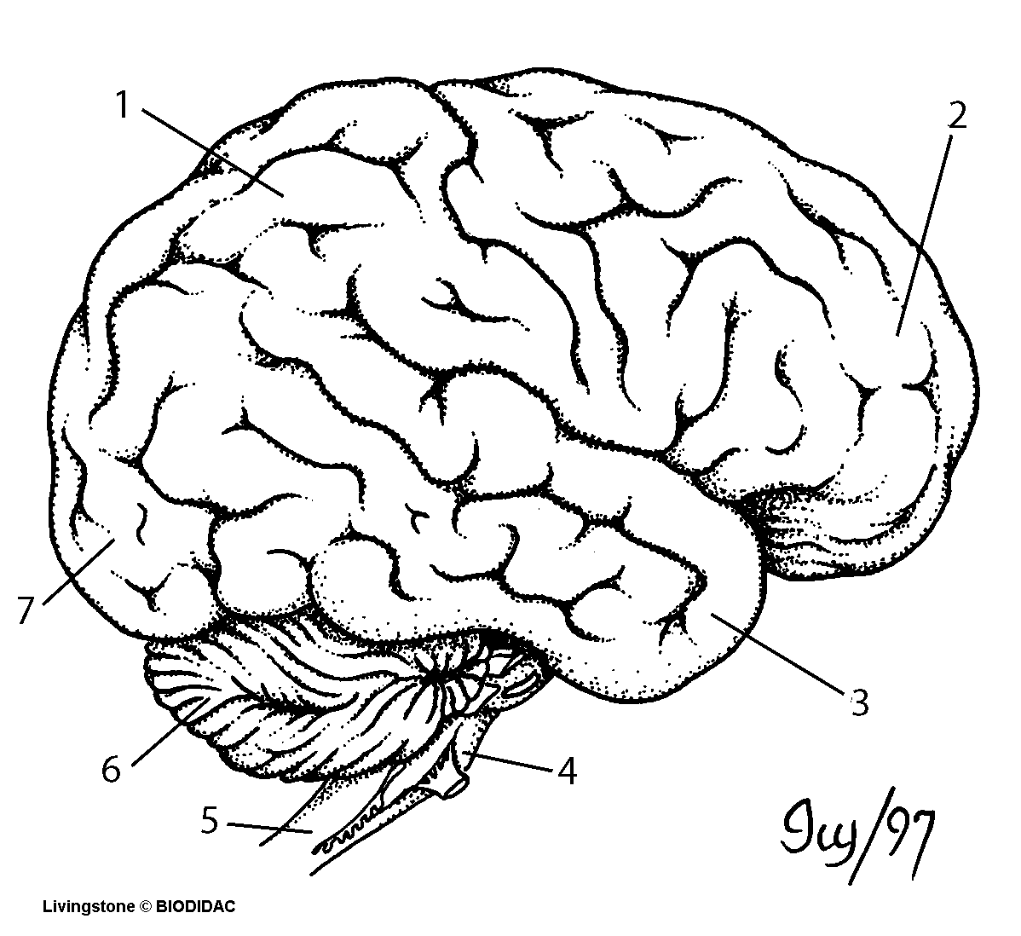

In your answer, you should:

* State and explain the functions of structures 1,2,3 & 7
* Explain the difference between voluntary and involuntary movement with reference to the structures of the brain
* Explain **two (2)** effects of damage to **two(2)** lobes of the brain
* Include at least **one (1)** piece of evidence to support your response